**INTRODUCTION**

This Data Perspective explores the month by month evolution of educational performance among 3 to 4 year old children in Zimbabwe using data from the 2019 MICS6 survey. The analysis focuses on key developmental areas: literacy and math, physical development, learning capabilities, and socio-emotional development.

**METHODOLOGY AND ANALYSIS**

The calculation of a child’s age in months is crucial for a more detailed analysis of development, especially when studying young children where even small differences in age can result in significant developmental changes.

You can see the R code (Task 2) for the calculation of a child’s age in months. I used variables **Interview_date** and **child_birthday** to get the age in days and convert days to months. I assumed that an average month length of 30.41 days (365 / 12).

I created four age month categories before visualization (36-41 months; 42-47 months; 48-53 months; and 54-59 months). Please refer to the R code (TASK 2) for these categories.

After categorizing, **the group_by ()** and **summarize ()** functions calculate the average proportion of children in each category who meet specific educational milestones.

I finally grouped age in months and calculate proportions for each educational area. For example, for the literacy rate, I calculate the proportion of children who responded "Yes" (1) to the question EC6 and EC7 dividing by the total number of valid responses (excluding missing or "Don't Know" responses). You see the R code (TASK 2) for the calculation.

This approach provides a clear, aggregated view of how children in different age groups perform in various educational areas. It allows for easier comparison between age categories, making trends more visible and actionable.

**RESULTS**

**Summary statistics**

|  |  |  |  |  |  |
| --- | --- | --- | --- | --- | --- |
| **age_category** | **LITERACY_rate** | **MATH_rate** | **PHYSICAL_rate** | **LEARNING_rate** | **SOCIO_EMOTIONAL_rate** |
| 36-41 months | 12% | 9% | 95% | 87% | 99% |
| 42-47 months | 10% | 13% | 95% | 89% | 99% |
| 48-53 months | 18% | 20% | 97% | 93% | 100% |
| 54-59 months | 25% | 29% | 97% | 93% | 99% |

**Visual**

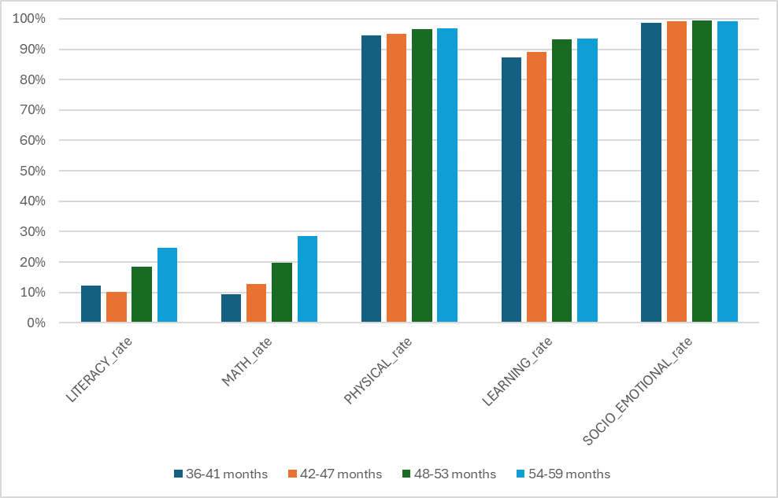**Proportion of Children Achieving Educational Milestones by Age Category**

**Key findings**

* The analysis reveals a steady increase in **literacy** (identifying letters) and **math** (recognizing numbers) abilities as children age from 36 to 59 months. By the age of 5, a significant proportion of children demonstrate foundational literacy and math skills.
* **Physical development**, measured by the ability to pick up small objects, shows consistent improvement with age. A sharp increase is observed around 48 months, suggesting a critical period for fine motor skills development.
* **Learning**: The ability to follow simple instructions and complete tasks independently also improves with age. This reflects the growing cognitive and behavioral maturity among children in this age group.
* **Socio-emotional** skills, such as getting along with other children and controlling aggressive behaviors, improve steadily but show variability, indicating diverse developmental timelines among children.

**CONCLUSION**

Understanding the evolution of educational performance month by month can help tailor educational programs to meet the needs of children at these crucial ages. Continued monitoring and targeted interventions are essential to ensure all children achieve their full potential.